Players Route

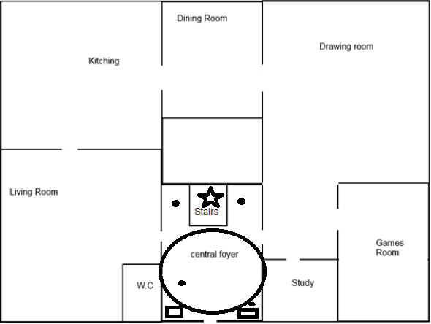
The player (Detective) will start in this
section here, in the central foyer, with the
two officers. There will be body (maids)
on the stairs, with clues scattered around
within the immediate area. For the first
part, everywhere will be accessible, but
only the central foyer will have objects
that can be interact with. The dots
signify where the clues will be placed
within the central foyer. The player will
have to collect clues to figure out
the case in order to progress through
the game. However, they do not have to
gather all of the clues as they can may
make an educate guess with only some
of them. The squares signify the officers that came with the player from the intro. They can be interact with and will have some dialogue to do with the current situation and the atmosphere with the manor. Their dialogue will change when the player interacts with the clues as the player will talk about how they found this or that clue. The star signifies the corpse of the first case that the player can also interact with. Additionally, the dialogue of the officers will change due to the actions of the player. As all of this is going on, the journal system will be updated when the player interacts with objects that is key to progression of the game. Once the player has finish with the ground floor, exploring the game layout and what not, they will go upstairs.

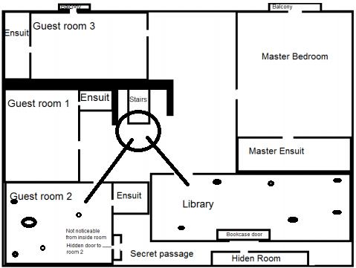
This is the first floor of the manor
and much like the first, the only
interacting the player can do is
inside the library where the first
puzzle will be and Guest Room 2.
There will be
objects inside the library that will
give mini descriptions of what they
are and if they are significant to
the player at all. The first puzzle
will be the bookcase puzzle. This
entails the player figuring out
the which books corresponds with
the right slot, within the bookcase.
There is up to four books the player
can choose from to input into the slot to progress to the secret passage. However, the player must figure it out as there will be only so many chances the player has before the game will punish them for getting it incorrect a number of times. Once the player has solved the puzzle for door will open up, with a sound of a door opening, to a secret passage where the player can inside the hidden room to collect something special. Alternatively, they can go straight next to the murder scene which is within Guest room 2. Like the foyer area, there will be clues scattered around the room that the player can interact with and will be added to the journal update section. They can explore the area but for now the library and Guest Room 2 is the only place of worth.

